**IT1060 – Software Process Modeling May-2023**

# Assignment 2 Cover Sheet

|  |  |
| --- | --- |
| **CASE STUDY NAME** | Payment Processing System |
| **PROJECT ID** | MLB_04.01_04 |

**Group Details:**





**BSc (Hons) in**

**Information Technology**



|  |  |  |
| --- | --- | --- |
|  | **Student Registration Number** | **Student Name** |
| **1** | IT22316486 | HEWAGAMA A D |
| **2** | IT22887108 | KUMARAGE N D |
| **3** | IT22336590 | SIRIWARDANA B J A |
| **4** | IT22326904 | ALWIS D A C |
| **5** | IT22338334 | SHEHARA I G D S |

**IT1060 – Software Process Modeling 2023 - May**

# Assignment 2 Certify Sheet

|  |
| --- |
| I hereby certify,  The attached is my own work and no further changes will be made.  I have contributed in this assignment to the best of my ability.  And I understand,  I may be subject to student discipline processes in the event of an act of academic misconduct by me including an act of plagiarism or cheating. |

|  |  |  |  |
| --- | --- | --- | --- |
|  | **Student Registration** |  |  |
| **Student Name** | **Number** | **Date** | **Signature** |
| HEWAGAMA A D | IT22316486 | 27/05/2023 |  |

**Student Details:**



**BSc (Hons) in**

**Information Technology**



**Part 1**

1)

|  |  |  |
| --- | --- | --- |
| **Number** | IT22316486 | |
| **Name** | Payment Processing System | |
| **Summary** | Manage payments | |
| **Pre-conditions** | User finds payment related form and start filling the form | |
| **Post-conditions** | Sent an email about successful payment to user | |
| **Primary actor (s)** | System user | |
| **Main Success Scenario** | **Step** | **Action** |
|  | 1 | System displays the payment form |
|  | 2 | Customer enters payment related details |
|  | 3 | System displays payment options |
|  | 4 | Customer selects payment options |
|  | 5 | System sends payment details to payment gateway |
|  | 6 | System validates payment input details |
|  | 7 | Payment gateway authorize transaction |
|  | 8 | Payment gateway process payment and confirm payment |
|  | 9 | System receives respond |
|  | 10 | System generates payment report |
|  | 11 | System displays successful payment by an email |
| **Extension** | 2a | System notifies payment related details are invalid |
|  | 6a | System provides the correct format to be entered |
|  | 9a | System display “payment not successful” |
|  | 9b | System display “try again” |

2)

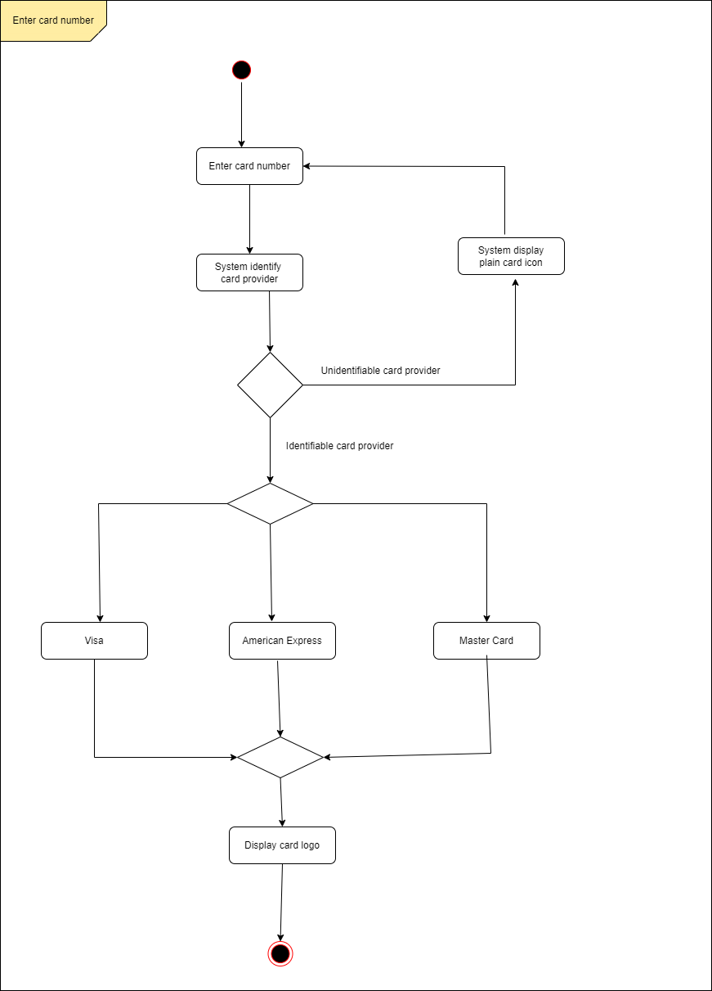

**PART 2**

1. a)

b)

1. Payment Processing System Swimlane

